GROUP REPRESANTATION

NAMES:-IRITARARENGA DieuMerci
-IMANZI GISA Marie Princesse
-IRAKIZA Honoline
-MUGISHA Olive

DISCUSS HOW PREPARE PYTHON AND MAKE REPORT.

SELECTION OF TOOLS
HARDWARE TOOLS
*processor
*memory
*storage
SOFTWARE TOOLS
*operating system
*python interpreter
*package manager
INSTALLATION OF PYTHON
STEP1: We download python version 3.13.7 from https://www.python.org/download/
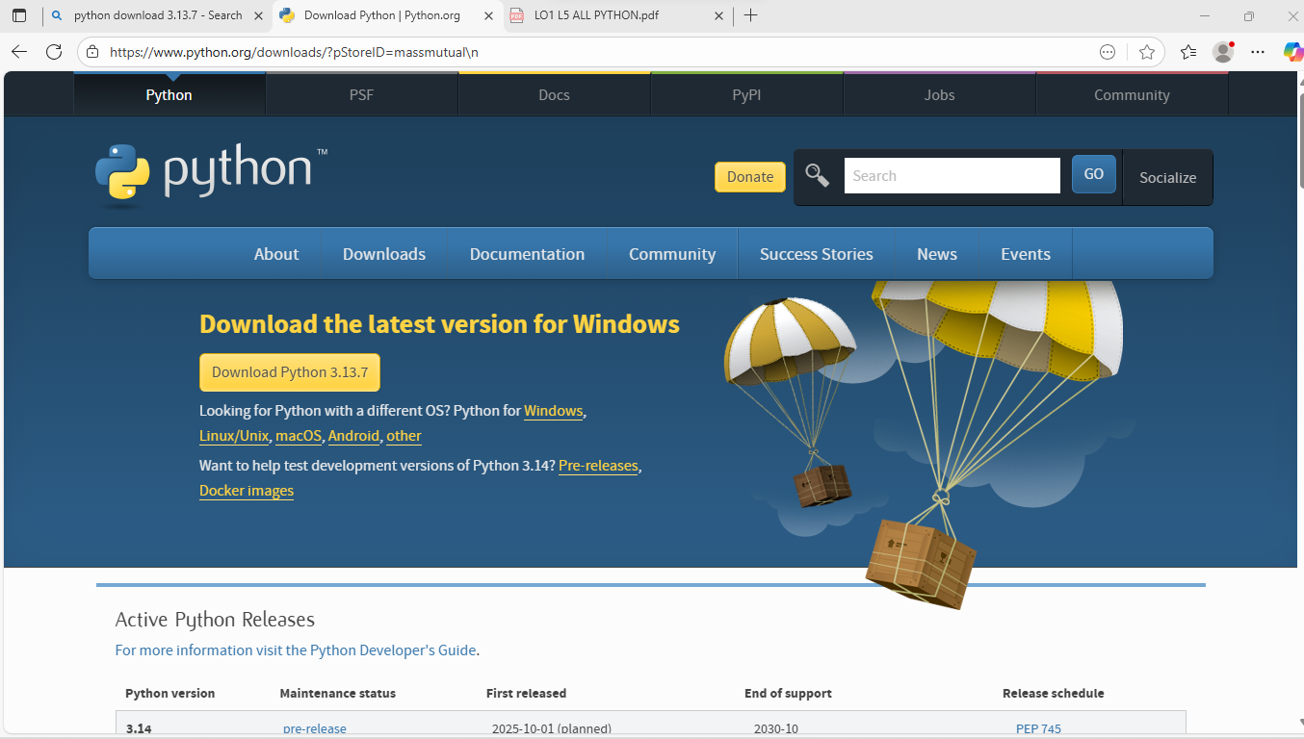
STEP2: Double click python set up version 3.13.7
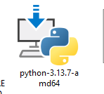
STEP3:Follow on-screen instructions
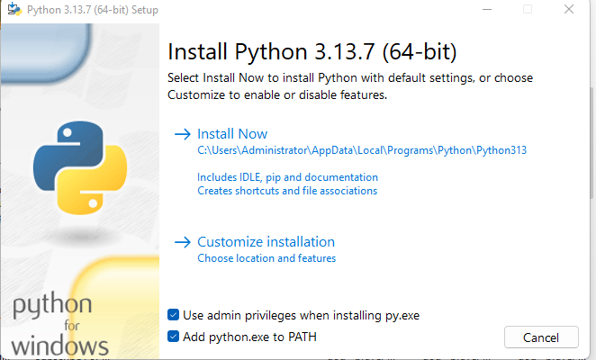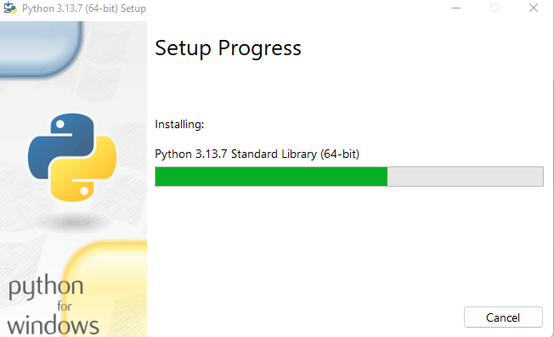
STEP4:After installation verify if installation was complete
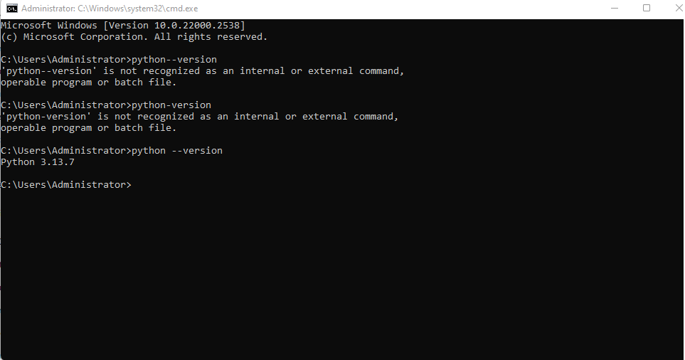
STEP5: Open python and we make simple programs
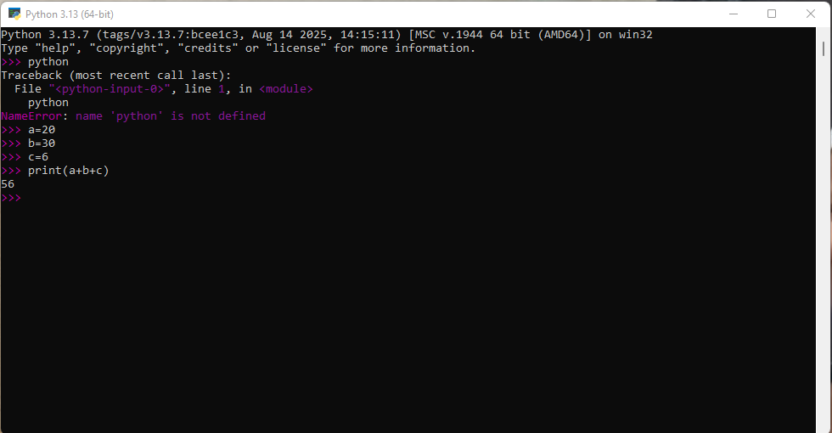
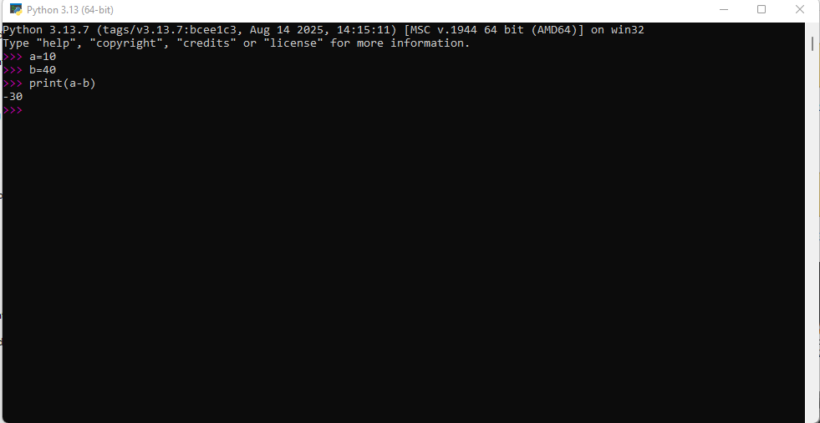

As conclusion: as we finish to install python we find out that it can be used in many and different ways such as mathematics and web development and data analysis.

